|  |
| --- |
|  |
| Create Site Map using Site & List Auditing |
| User Guide |
|  |
|  |
| **Last Updated: 10/20/2022** |

|  |
| --- |
|  |

This document will provide users with instructions on how to create a SharePoint Site Map using QiPoint’s SharePoint Site & List Auditing™ tool.

Table of Contents

Introduction 2

Minimum Requirements 3

Steps 4

Technical Support **Error! Bookmark not defined.**

# Introduction

This document will show you how to export a report from the SharePoint Essentials Toolkit into MS Visio to build a visual site map of your SharePoint sites and or lists.

# Minimum Requirements

* Microsoft SharePoint 2013, 2016, 2019
* Microsoft SharePoint Online
* SharePoint Essentials Toolkit v5.2.0.0 or higher
* Microsoft Visio 2010 or higher

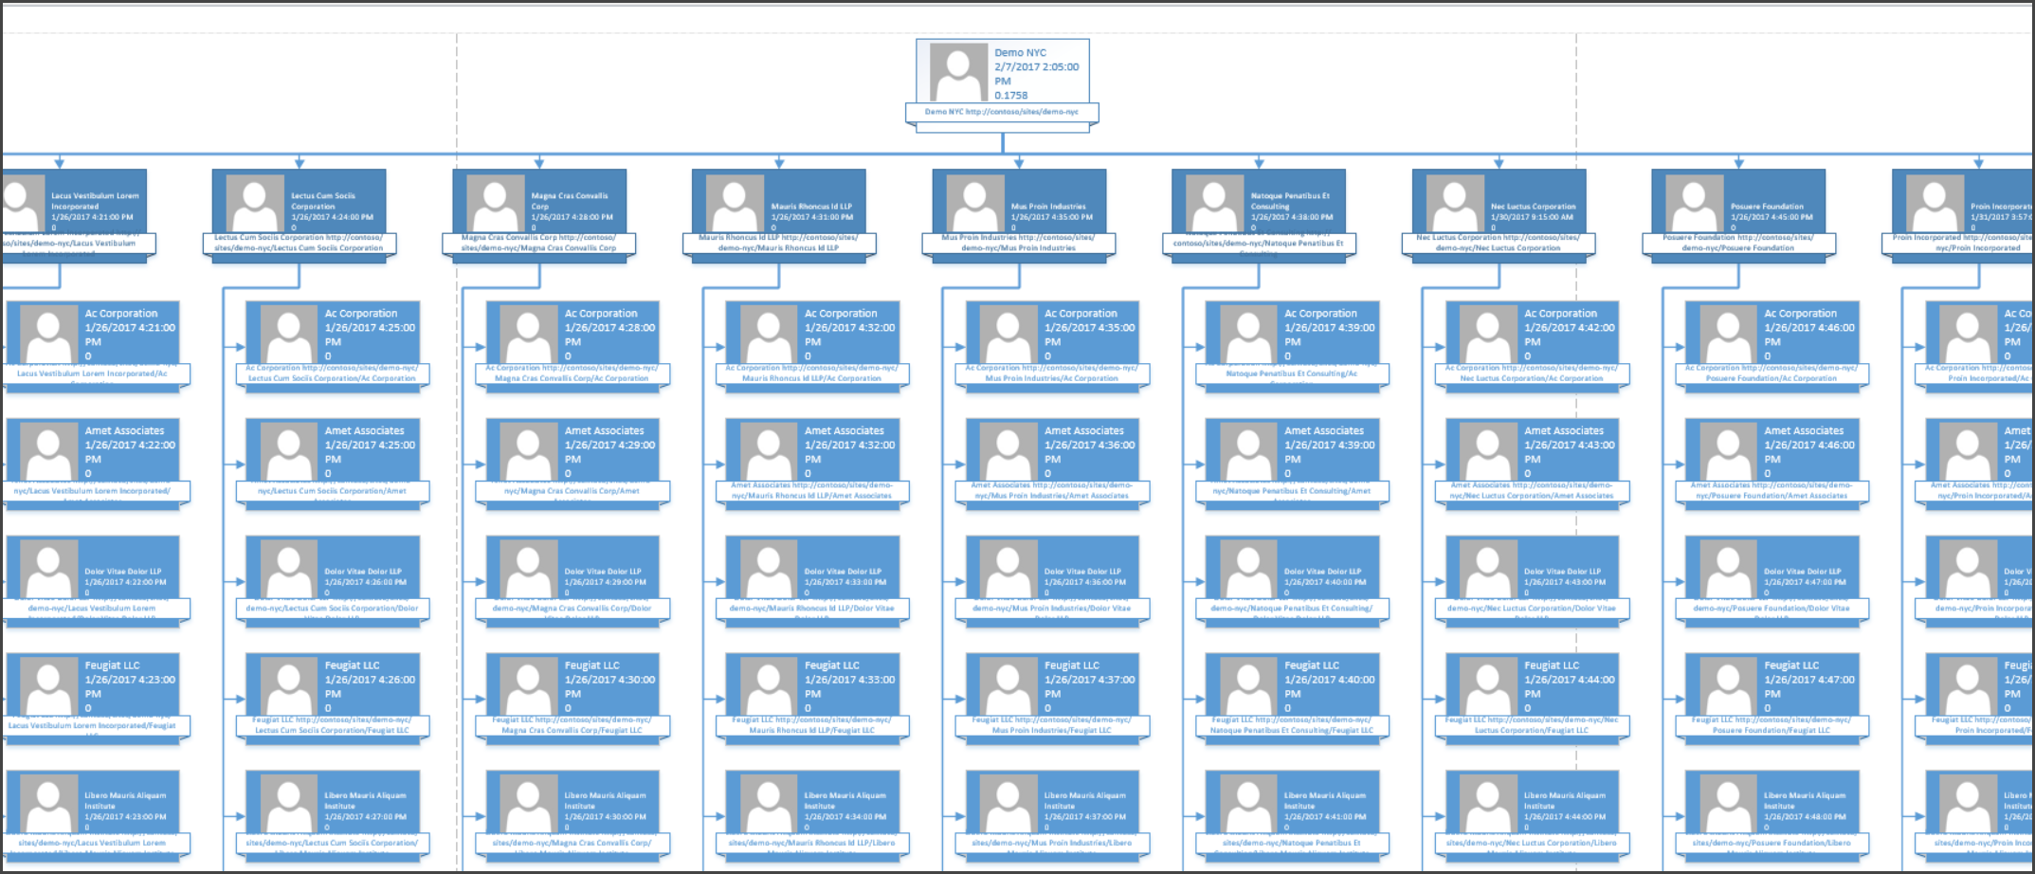

# Step by Step

1. Open ‘SharePoint Essentials Toolkit’ application.
2. If you have not done so already, create Site Audit reports for the sites you want to build a Site Map for. First, select multiple sites from the Home Page Dashboard, right click and select ‘Create Reports -> Site & List Inventory’. (See ‘SharePoint Site Auditing - User Guide’ for more information.)

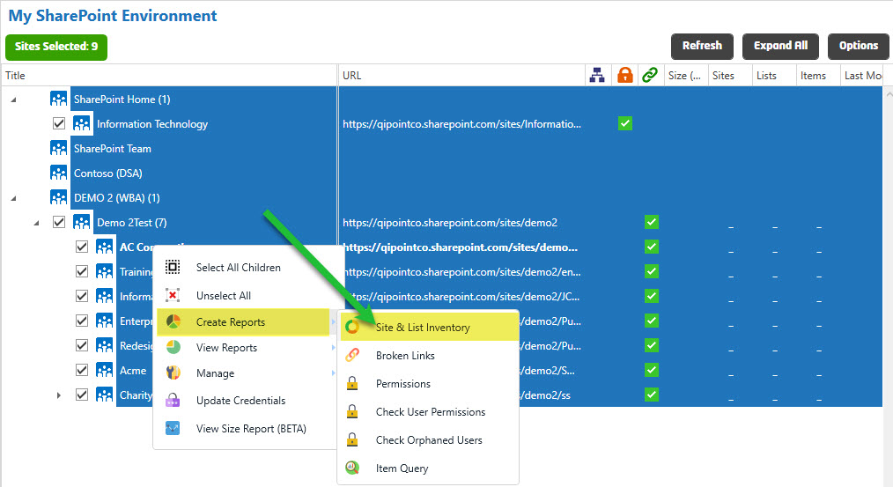

1. After you have created the Site Audit reports (for example, through ‘Schedule Job’ or ‘Run Now’ function from the “Create Site & List Inventory Job” window), click ‘Sites’ from the Top Navigation menu, and then select ‘Reports -> Site Inventory’ option from the Left Navigation menu.

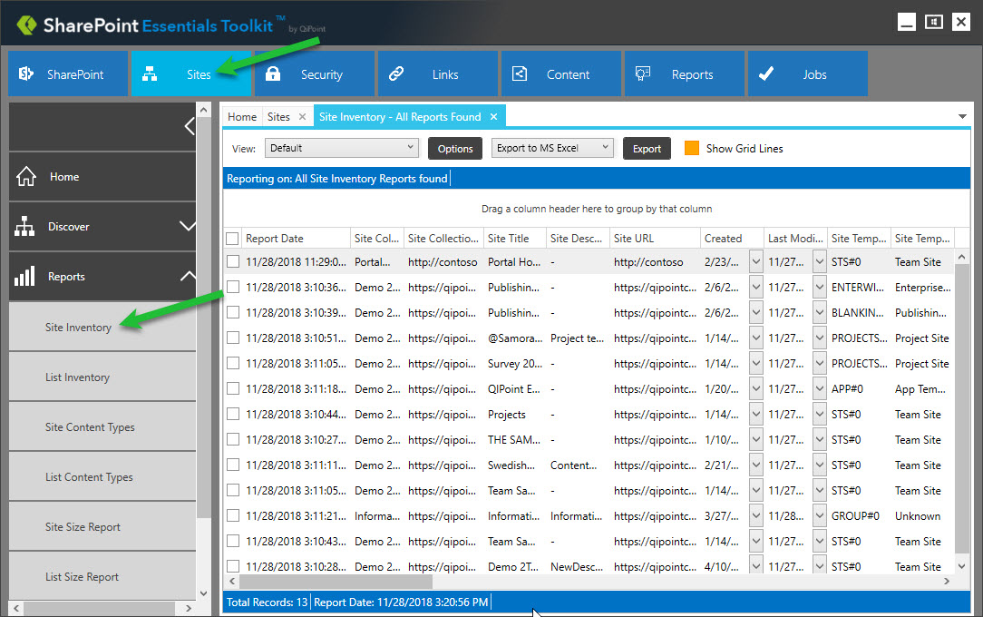

1. This will launch a new window for all ‘All Site Inventory’ for the sites you previously selected.
2. OPTIONAL: Filter the sites and site collections you do not want in the site map.
3. Click the ‘Export’ button at the top of the window. (The MS Excel application launches.)

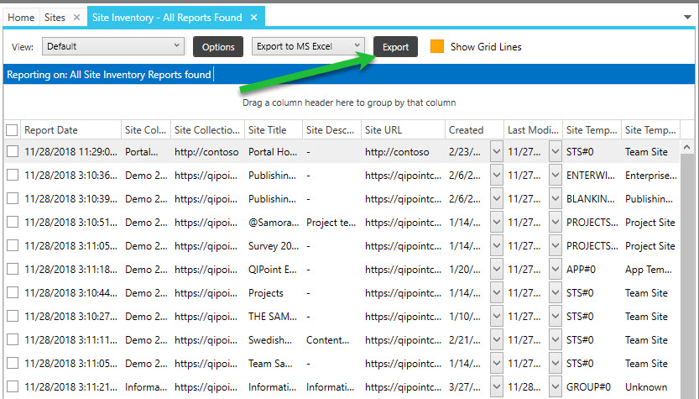

1. In the MS Excel application, click ‘File -> Save As’ -> Save’ to save the file.
2. Open MS Visio.
3. In MS Visio, click ‘File -> New’.
4. Select the ‘Organization Chart’ template.

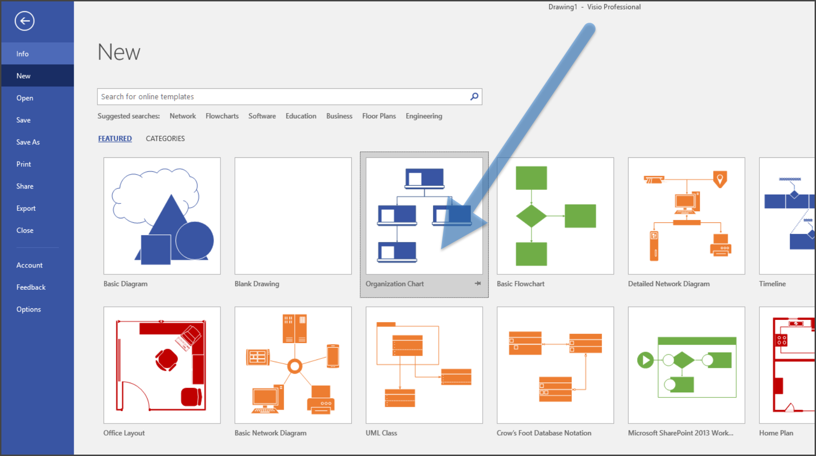

1. Click the ‘Create’ icon. (The ‘Organization Chart Wizard’ window appears.)

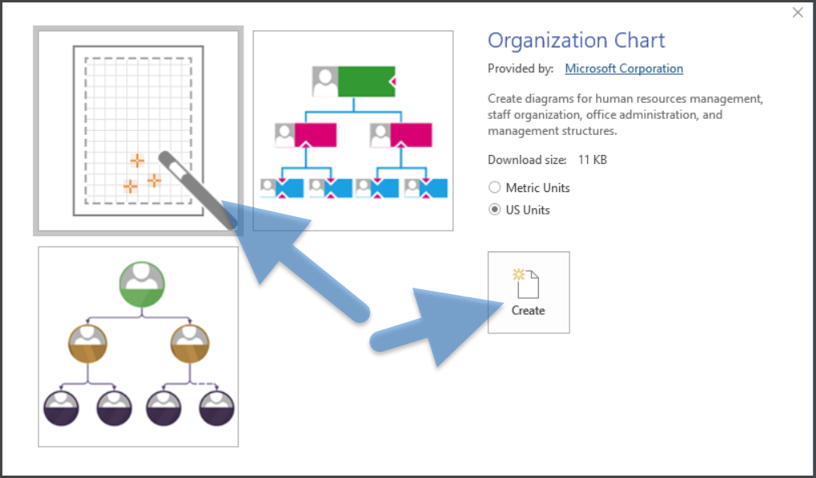

1. Click the ‘Next’ button.

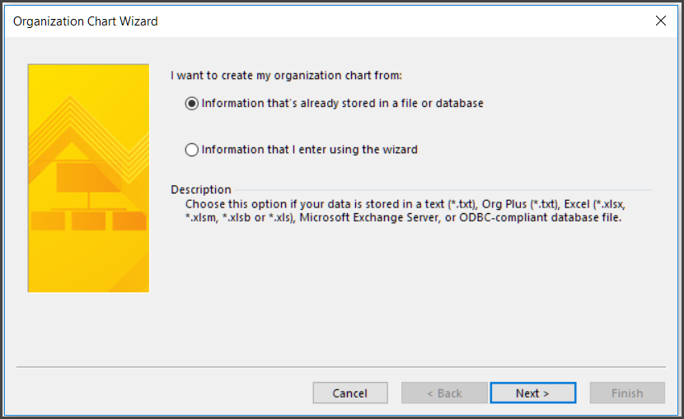

1. Click the ‘Next’ button.

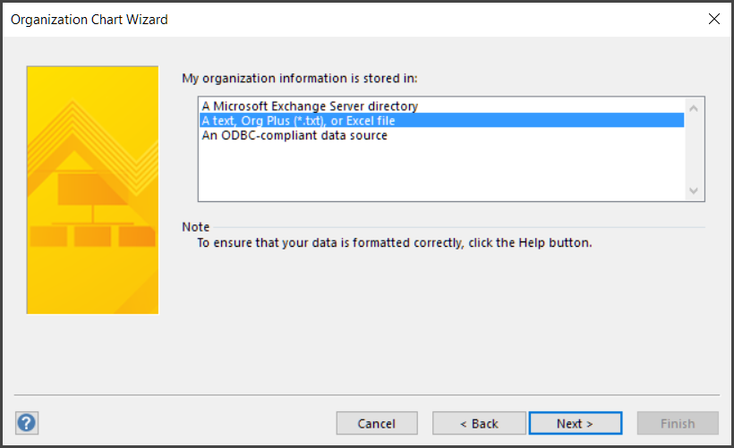

1. Click the ‘Browse…’ button and locate the Site Inventory report saved previously, in Step 7. After locating the report, click the ‘Next’ button to proceed.

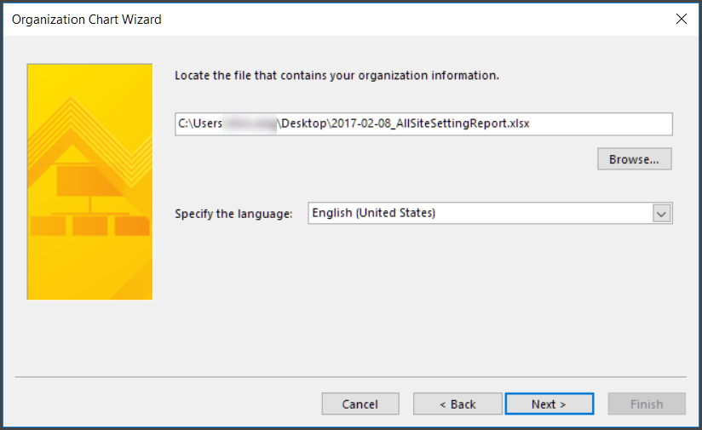

1. Select the options below, and then click the ‘Next’ button.
   * Web Id
   * Parent Web Id
   * Site Title

**Note**: You can change “Web ID” to “Site URL,” depending on what you want to display in the Site shape in Visio.

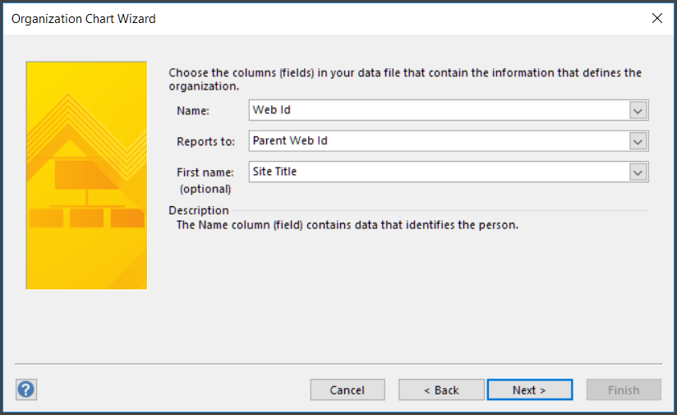

1. Select the options below, and then click the ‘Next’ button.

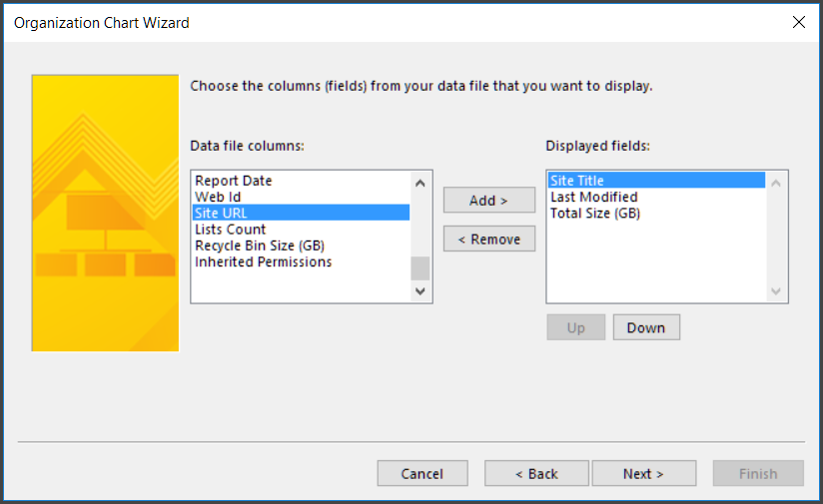

1. Select/verify your options below, and then click the ‘Next’ button.

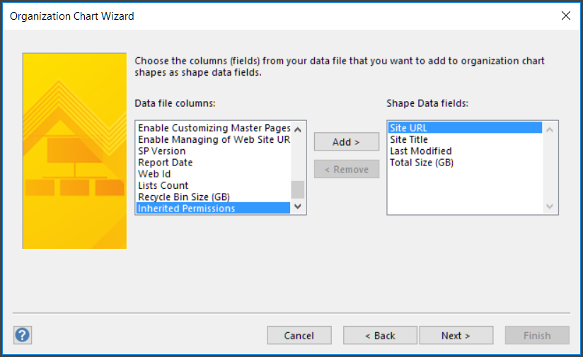

1. Select ‘Don’t include pictures in my organization chart’, and then click the ‘Next’ button.

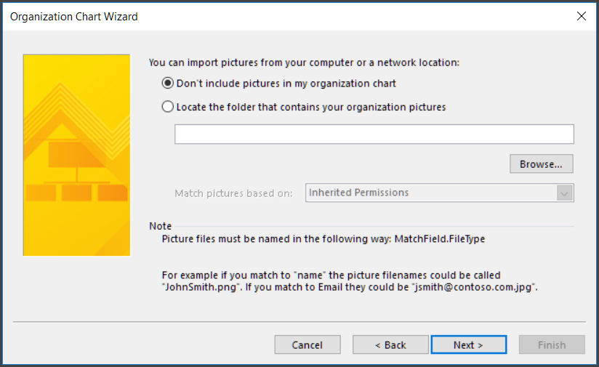

1. You should see the root site(s) listed here:

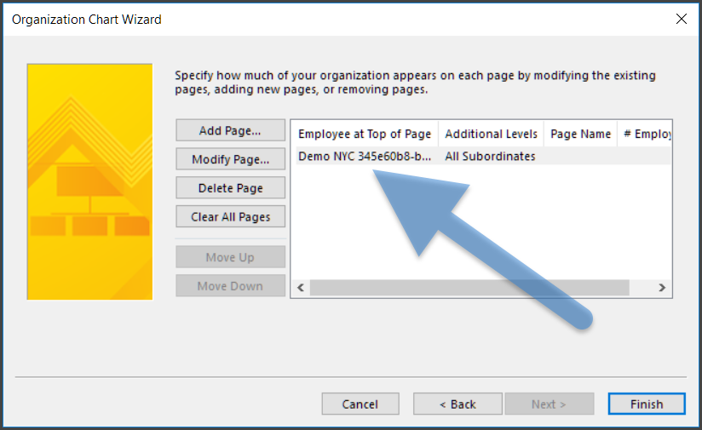

1. Click the ‘Finish’ button. (The SharePoint Site Map should generate like the one below.)

